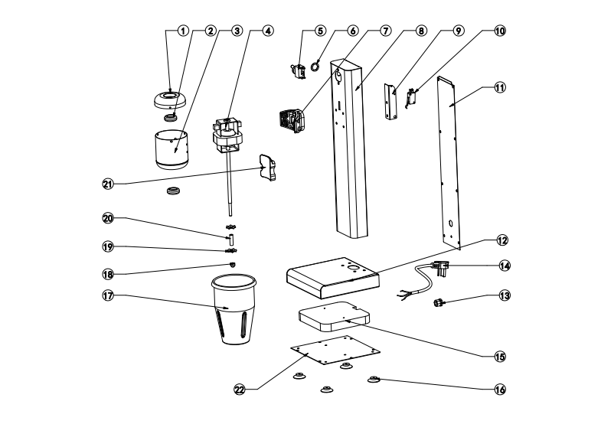

|  |  |  |  |  |  |
| --- | --- | --- | --- | --- | --- |
| **No.** | **Name** | **Qty.** | **No.** | **Name** | **Qty.** |
| **1** | **Cover** | **1** | **12** | **Base** | **1** |
| **2** | **Silicagel** | **2** | **13** | **Cablehead** | **1** |
| **3** | **Enginecup** | **1** | **14** | **Powercable** | **1** |
| **4** | **Motor** | **1** | **15** | **Gravitationalplate** | **1** |
| **5** | **Three-speedswitch** | **1** | **16** | **RubberFeet** | **4** |
| **6** | **Screw** | **1** | **17** | **Milkshakercup** | **1** |
| **7** | **Plasticstent** | **1** | **18** | **ScrewM6** | **1** |
| **8** | **Column** | **1** | **19** | **Rotor** | **2** |
| **9** | **Supportplate** | **1** | **20** | **Φ8tube** | **1** |
| **10** | **Microswitch** | **1** | **21** | **Plastichanger** | **1** |
| **11** | **BehindBoard** | **1** | **22** | **Baseboard** | **1** |

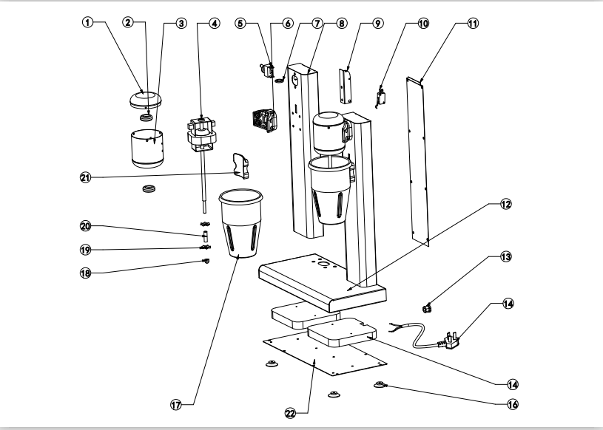

|  |  |  |  |  |  |
| --- | --- | --- | --- | --- | --- |
| **No.** | **Name** | **Qty.** | **No.** | **Name** | **Qty.** |
| **1** | **Cover** | **2** | **12** | **Base** | **1** |
| **2** | **Silicagel** | **4** | **13** | **Cablehead** | **1** |
| **3** | **Enginecup** | **2** | **14** | **Powercable** | **1** |
| **4** | **Motor** | **2** | **15** | **Gravitationalplate** | **2** |
| **5** | **Three-speedswitch** | **2** | **16** | **RubberFeet** | **4** |
| **6** | **Screw** | **2** | **17** | **Milkshakercup** | **2** |
| **7** | **Plasticstent** | **2** | **18** | **ScrewM6** | **1** |
| **8** | **Column** | **2** | **19** | **Rotor** | **4** |
| **9** | **Supportplate** | **2** | **20** | **Φ8tube** | **2** |
| **10** | **Microswitch** | **2** | **21** | **Plastichanger** | **2** |
| **11** | **BehindBoard** | **2** | **22** | **Baseboard** | **1** |