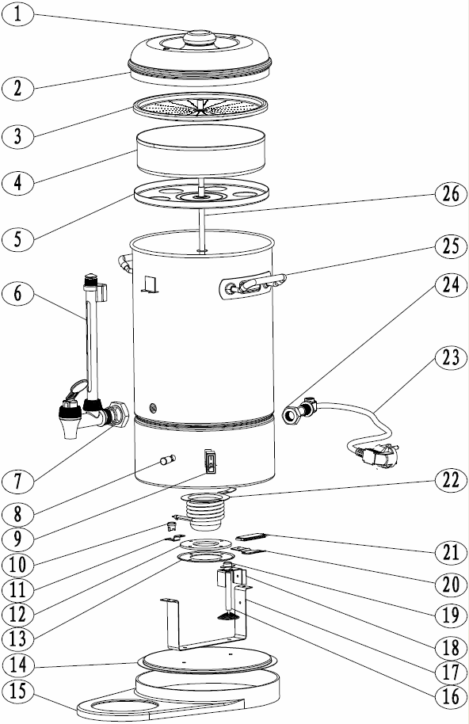
CCode | description | Quantity
1 | Handlebar | 1
2 | Top Lid | 1
3 | Seieve basket | 1
4 | Tray | 1
5 | Orientation Tray | 1
6 | Tap component | 1
7 | Root Screw | 1
8 | Indicator light | 1
9 | On/Off | 1
10 | Thermostat | 1
11 | Thermostat shell | 1
12 | Pressurize | 1
13 | circle | 1
14 | Bottom board | 1
15 | Bottom | 1
16 | Diaplasis pole | 1
17 | Support shell | 1
18 | Frame | 1
19 | portect switch | 1
20 | PTC- Frame | 1
21 | PTC-Resistance | 1
22 | Heating component | 1
23 | Power component | 1
24 | clip | 1
25 | Holder | 2
26 | Nozzle pipe | 1

