MEAT MINCER HM-12/HM-22
-EXPLODE DRAWING

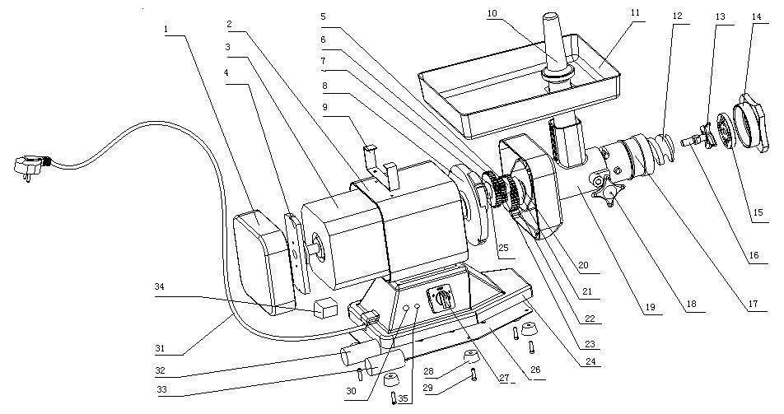
Part No. | Description |  | Part No. | Description
1 | HELL COVER |  | 14 | SCREW COVER
2 | BODY |  | 15 | DISK
3 | MOTOR |  | 16 | BLADE SHAFT
4 | MOTRO HEEL COVER |  | 17 | MINCER BLOCK
5 | SMALL SHAFT |  | 18 | LOCKING HANDLE
6 | RUN GEAR( SAMLL ) |  | 19 | SHELL
7 | RUN GEAR ( BIG ) |  | 24 | WORK TABLE
8 | FACE-COVER |  | 26 | BOTTOM BOARD
9 | BRACKET |  | 27 | INDUSTRIAL SWITCH
20 | OIL ENVELOP |  | 28 | RUBBER FEET
21 | BIG SHAFT |  | 29 | RUBBER FEET SCREW
22 | GEARWHEEL |  | 30 | PUSH-BUTTON SWITCH
23 | MOTOR GEAR |  | 31 | POWER PLUG
25 | SMALL GEAR( BACK ) |  | 32 | MOTOR-RUN CAPACITOR 22mf
10 | PESTLE |  | 33 | MOTOR –START CAPACITOR 300mf
11 | FOOD TRAY |  | 34 | RELAY
12 | SCREW FEEDER |  | 35 | STOP BUTTON SWITCH
13 | KNIFE

